**APPOINTMENTS**

Doctor: All Consultations by Appointments.

Appointment Times:

Monday 8.05am - 10.40am

2.15pm - 5.40pm

Tuesday 8.05am - 10.40am

2.15pm - 5.40pm

Wednesday 8.05am - 10.40am

2.15pm - 5.40pm

Thursday 8.05am - 10.40am

2.15pm – 5.40pm

Friday 8.05am - 10.40am

2.15pm - 5.40pm

Saturday/Sunday: Closed

## OUT OF HOUR CALLS

For an ***Emergency*** outside surgery opening hours please ring 01204 463636.

HOME VISITS:

Home visits are for people who are housebound or seriously ill. If you can get to surgery, please do so. Please telephone for a home visit between 8.00am and 10am.

PRACTICE NURSES:

Nurse appointments are pre-booked. Please ask the receptionist if you need to book to see the nurse. Appointments may be booked up to 3 months in advance.

**NAMED ACCOUNTABLE GP**

All patients (including children) are allocated a Named Accountable GP, as required under the GMS Contract. Please ask at reception should you wish to know who your Named Accountable GP is.

You can continue to see any Doctor or Nurse of your choice and your clinical care will not be affected.

**GENERAL SURGERY INFORMATION**:

We operate a complaints procedure, which complies with current NHS guidelines. Please ask a Receptionist if you require details.

We participate in a new Government policy based on ‘Zero Tolerance’ of violence and aggressive behaviour from patients and other visitors. Unreasonable, threatening behaviour will not be accepted by the practice.

**The practice operates a policy for patients who continually fail to attend their appointments. This may result in the patient being removed from the list**

CHANGE OF PERSONAL DETAILS:

If you change your name, address or telephone number, it is important that you inform the surgery as soon as possible. Please give full details to the receptionist including your postcode.

The location of the surgery is shown below:

If your place of residence is not within the boundary below we are unable to register you as a patient.



## RECEPTION OPENING TIMES

Monday 8.00am - 6.30pm

Tuesday 8.00am - 6.30pm

Wednesday 8.00am - 6.30pm

Thursday 8.00am - 6.30pm

Friday 8.00am - 6.30pm

Saturday/Sunday: Closed

## STAFF

**Dr Gillian Counsell MB ChB**

**Dr Mohamed Arif Mirza MRCGP, MB ChB DRCOG, PG Dip (Derm)**

**Dr Khalil Sonara MB ChB**

**Dr Alicia Speller MB BCh**

**Dr Robert Walker MB ChB**

Practice Manager – Linda Cassells Gregson

Prescribing Pharmacist

3 Practice Nurses

Health Care Assistant

Health Trainer

Counsellor

Secretary/Receptionists

Attached Midwives, Health Visitors, District Nurses.

## REPEAT PRESCRIPTIONS (Telephone between 11am-2.30pm)

Or at reception using your tear-off slip, by letter including a stamped addressed envelope, or via the internet at **www.drcounsellandpartners.co.uk**

Please allow 48 working hours before collecting your prescription

**ADDITIONAL CLINICS/SERVICES:**

PHLEBOTOMY (blood tests):

This service is available at the practice

Please ask at reception

**TEST RESULTS:**

You may contact the surgery one week after the tests for your results. Please try to avoid telephoning between 8.00am – 10.45am as the reception is very busy at this time. Please note; some test results do take longer to be generated by the hospital

(i.e. x-rays can be up to two weeks)

**MIDWIFE:**

Ask the receptionist at the surgery.

**COUNSELLING SESSIONS:**

Ask the receptionist at the surgery.

## USEFUL CONTACTS

**111 Service**

This is a freephone number for medical advice when the GP surgery is closed.

**Bolton CCG**

#### St Peter’s House

Silverwell Street

Bolton

BL1 1PP

#### Telephone 01204 462000

Bolton Health Information Centre, Lever Chambers, Bolton: Tel 01204 462600

General Information to the public regarding

GP practices and other health services in the region.

## The Parallel, 9a Churchgate, Bolton

Telephone or text: 07900 918297

Confidential medical advice, sexual health advice and counselling for young people – self-referral, no appointment needed.

**APPOINTMENTS ARE ALSO AVAILABLE EACH WEEK** **FOR THE FOLLOWING:**

Asthma

Diabetes

CHD (coronary heart disease)

COPD (chronic obstructive pulmonary disease)

Spirometry

Blood pressure

Flu injection

Travel vaccinations

Smoking cessation

Smears

Contraception advice/pill check

Health checks

Antenatal clinic – by Midwife

Phlebotomist (blood test)

Treatment room procedures (dressings etc.) – by District Nurse.

Unless otherwise stated, the above are run by the Practice Nurse(s) and are available by appointment only.

**INTERPRETATION SERVICES ARE AVAILABLE**

**VIA A TELEPHONE LINE, PLEASE ENQUIRE AT**

**RECEPTION WHEN BOOKING AN APPOINTMENT**

# PRACTICE LEAFLET

# Dr. Counsell & Dr.Mirza

Pikes Lane Centre

Deane Road

Bolton BL3 5HP

# Telephone: 01204 463636

# Fax No: 01204 463635

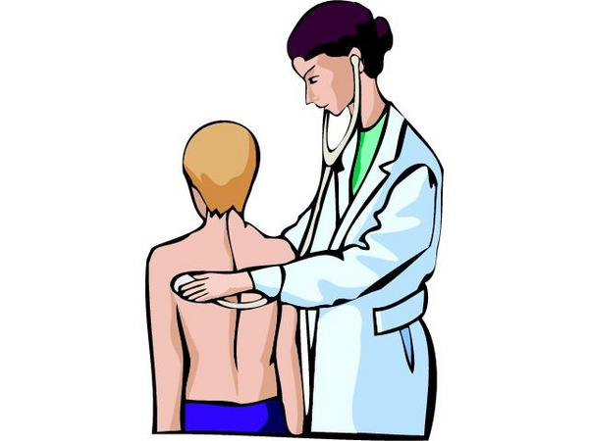

May 2016